# Introduce new C# 7.0 features

## Introduction

This sample introduces new C# 7.0 features.

## Sample prerequisites

This sample solution needs Visual Studio 15, please download the latest [VS 15](https://www.visualstudio.com/en-us/downloads/visual-studio-next-downloads-vs.aspx).

## Running the sample

* Open Visual Studio 15, click open project in the menu and navigate to open the “CS70Sample.sln” file

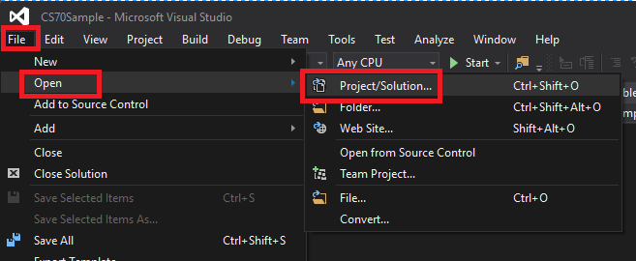

* Right click solution “CS70Sample” in Solution Explorer, and click “Restore Nuget Package”

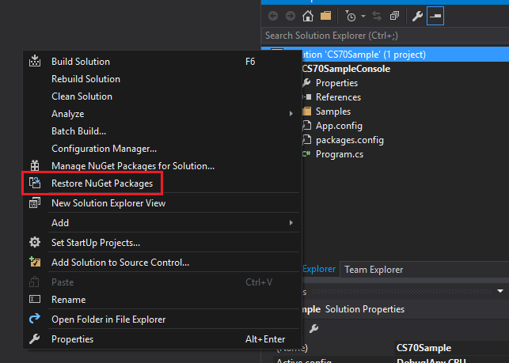

* Then read the code or debug it as you wish

## Using the code

This sample demonstrates 7 new C# 7.0 features

* Out variables
* Pattern matching
* Tuples
* Deconstruction
* Local functions
* Digit separator
* Ref returns and locals

## Out variables

C# 7.0 has the ability to declare an out variable at the point which it is passed as an out argument

<code snip>

## Pattern matching

C# 7.0 introduces “pattern matching” abstract to determine the value for “Type, value” and then extract it if the test passes

In the sample, we will demonstrate 3 different kinds of patterns

* Type pattern
  + Determine the type of the value and then assign the value to the new type identifier if test passes
* Constant pattern
  + Determine the value and test whether it equals to the value to be tested
* Var pattern
  + Create a new identifier to assign the value of original value

And there are 2 different approaches to apply the patterns listed above

* Is expression

<code snip>

* Switch statement

<code snip>

## Tuples

C# 7.0 provides an easy solution by returning the tuple from a function rather than using the long template tuple class type

<code snip>

**Notes:** currently the tuple feature depends on the “System.ValueTuple” package, you can search it on nuget.org by checking “Include prerelease”

## Deconstruction

C# 7.0 can split the tuple value into individual variables

<code snip>

You can also deconstruct a class instance if the class has an instant method or an extension method in the form: **public void Deconstruct(out T1 x1, out T2 x2, .., out Tn xn) { … }**

<code snip>

## Local functions

Now you can define a function inside the function like javascript

<code snip>

## Digit separator

C# 7.0 allows _ as a digit separator, it makes the code clearer if the number is too long to read

<code snip>

## Ref returns and locals

C# 7.0 can now return a ref type value.

<code snip>

## More information

* VS 15 download: <https://www.visualstudio.com/en-us/downloads/visual-studio-next-downloads-vs.aspx>
* C# 7.0 first-hand look: <https://blogs.msdn.microsoft.com/dotnet/2016/08/24/whats-new-in-csharp-7-0/>